# Docker

1. **Download** Docker from

[*https://www.docker.com/products/overview*](https://www.docker.com/products/overview)

1. **Install** Docker by unpacking the downloaded file
2. **Verify** the Installation by opening a command-line terminal and try following commands:

*docker version*

&

docker run hello-world

**Output Screen:**

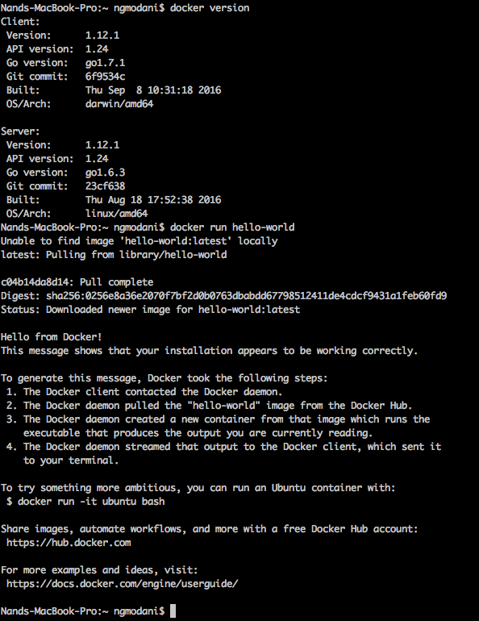

1. Create an account on <https://hub.docker.com/>
2. **Sample Example** to create Docker Image to run a Python web app.
   1. **Create** a docker file (plain text file with no extension) and name it “Dockerfile” and type in following commands.

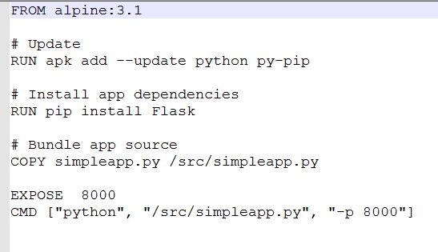

* 1. **Save** above file in a folder
  2. **Create** following python file and save it with name “simpleapp.py”

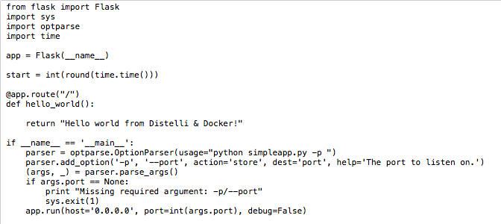

* 1. **Build** the Docker image of you file

*Docker build –f <fileName> <location of file>*

In below example, we’re building the Docker Image of file name “Dockerfile” (we created above) which is located in my current working directory, hence location is simply “.” After successful completion of the command, we can see an image ID is generated. (here it is “*98852dd6b0ed*”)

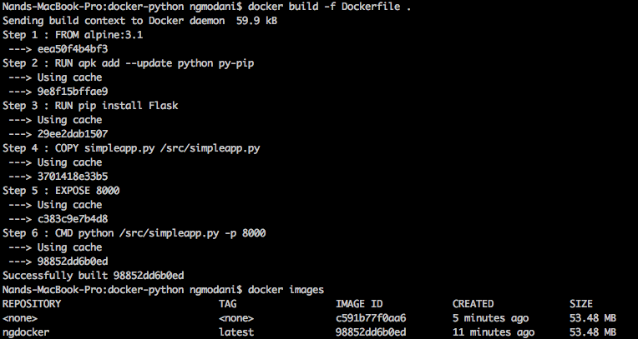

* 1. **Login** with your docker hub credentials

*Docker login*



* 1. **Create** a tag of this image and push it in docker hub: this step is to make your container a public and reusable image. (tag works like a version of your work)

**For tagging**

Docker tag <image ID> <username>/<image-name>:<tag>

*Docker tag 98852dd6b0ed ngmodani/ngdocker:latest*

**For pushing**

Docker push <username>/<image-name>

*Docker push ngmodani/ngdocker*

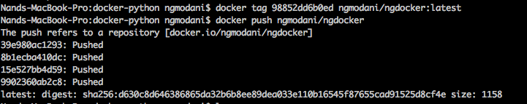

* 1. To verify your creation, login to your Docker hub account ad you can see your image there.

1. To run this image in any other machine, where Docker is installed. And then check its status

**To Run**

*docker run -d -p 8000:8000 ngmodani/ngdocker python /src/simpleapp.py -p 8000*

**To Check**

*docker ps -l*



1. Open your web browser and enter URL “localhost:8000”. You will see following page.

